Please join RIDSS for an open discussion with
Anne Tucker Roberts,
author of Five Courageous Mothers

Anne’s honest and candid presentation is applicable to ANYONE who has a relationship with a person with a disability –
A child, sibling, cousin, co-worker, friend, support staff.

Refreshments served - ALL are welcome to attend!

“These stories are about five remarkable women who have overcome so many challenges that their accomplishments stand as a tribute to the courage and steadfastness of all women. Everyone who wants inspiration should read this book.” Mary Jordan, Merrimack, NH

Wednesday, July 31st 6pm
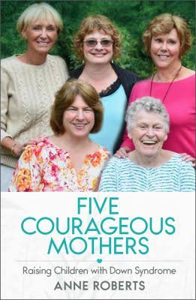
Bristol Train of Artillery Museum
135 State Road, Bristol, RI

Anne Tucker Roberts is a gifted teacher and writer. For nearly two decades, she taught adolescents with developmental disabilities. After
12 years in this position, Anne was recognized as a Master Teacher and awarded a “Golden Apple” for professional excellence. This book is the result of a new collaborative work between Anne and these remarkable mothers. Anne graduated from Boston College with a BA in Liberal Arts. She later earned a Master’s in Education and a Master’s in Special Education. She continues her work as a guardian for four women with developmental disabilities. She lives with her husband of 30 years in Scituate, MA.

